|  |
| --- |
| Apache Lucene Tutorial -1 | Solr Search |

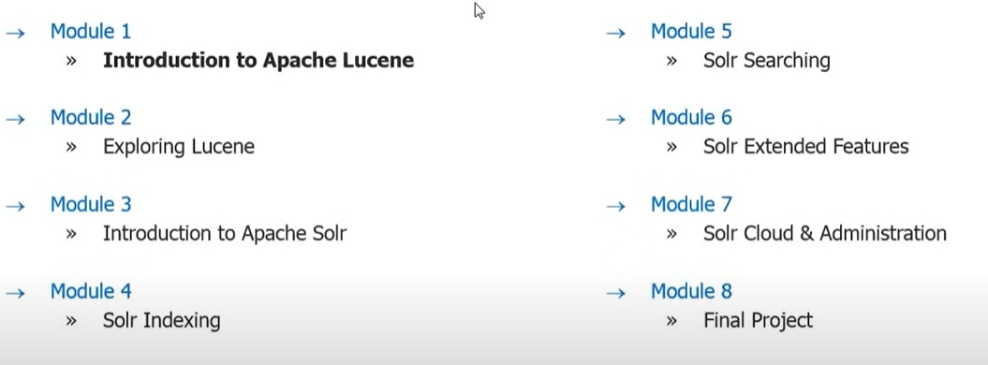

Sorl is enterprise grade web search platform built on top of lucene

**Index document and make it searchable**

Lucene takes document and index the documents.

Crawlers can take documents from the web and give data to lucene . And lucene can index the received data.

Doug Cutting “Creator” of lucene.

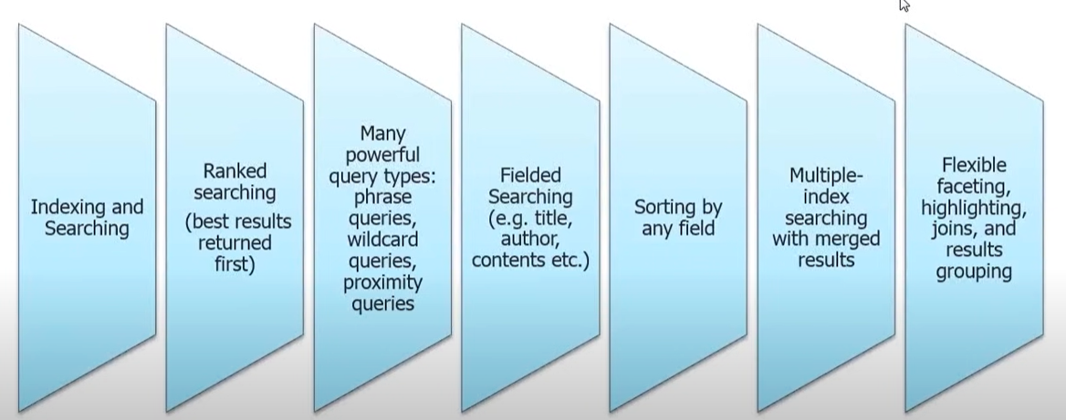

|  |  |
| --- | --- |
| Indexing and Searching |  |
| Ranked searching (best results returned first) | Wild cards or prefix queries or Boolean queries. |
| Many powerful query types: phrase queries, wildcard queries, proximity queries |  |
| Field searching (e.g. title, author, contents etc.) |  |
| Sorting by any field |  |
| Multiple index searching with merged results |  |
| Flexible faceting, highlighting, joins and results grouping |  |

Block indexing or incremental indexing—it accumulates all the index and updates them in incremental order it does not cause changes in immediate changes.

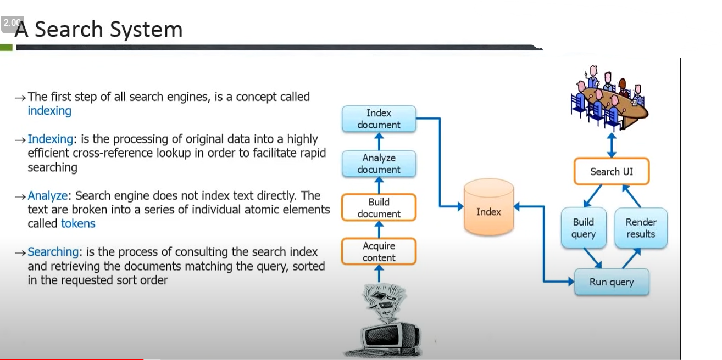

|  |
| --- |
| The first step of all search engines, is a concept called indexing |
| Index: is the process of original data into a highly efficient cross-reference lookup order to facilitate rapid searching |
| Analyze: Search engine does not index text directly. The text are broken into a series of individual atomic elements called tokens. |
| Searching: is the process of consulting the search index and retrieving the documents matching the query, sorted in the request sort order. |
|  |

Stemming while indexing.

Retrieve the true base while indexing.

**The most important step before indexing is analysis.**

|  |
| --- |
| **As for search phase lucene refers to it as querying. Is the process of going and getting a document as per query.**  **Pure Boolean model: no scoring is done when a score is not done.scoring is ranking documents**  **In Boolean query there is no sorting.**  **Vector Space model:**  **When query is written query is transform into vector dimensional data and the data collected is transformed into vector and intersecting documents is returned as relevancy or similities.The more the documents some weight of similarities the documents shows up**  **Vertor based queries** |

**Search engine indexing collects, parse, and stores data to facilitate fast and accurate information retrieval.**

**The purpose of storing an index is to optimize speed and performance in finding relevant documents for search query.**

**Solr is not for structured data.**

**How indexing occurs**

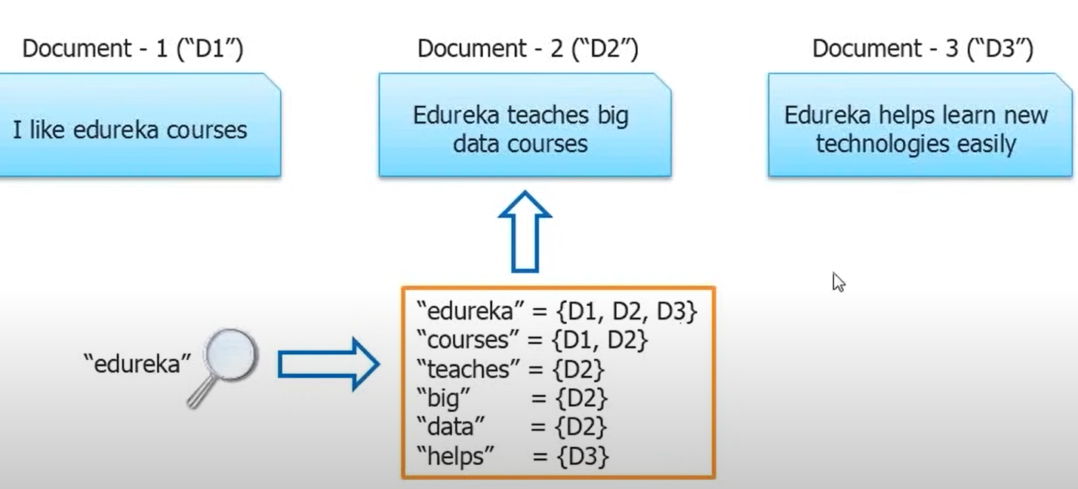

**Indexing Flow**

|  |
| --- |
| When a document is submitted. The analysis is the first step.  When the document is analysed the document is tokenized. And the tokenized text is indexed  Into an Inverted Index. The tokenization produces Term Vector(word—position,offset,length) for each token. Term vector is a small data structure that serves as a lookup for a token in document. |

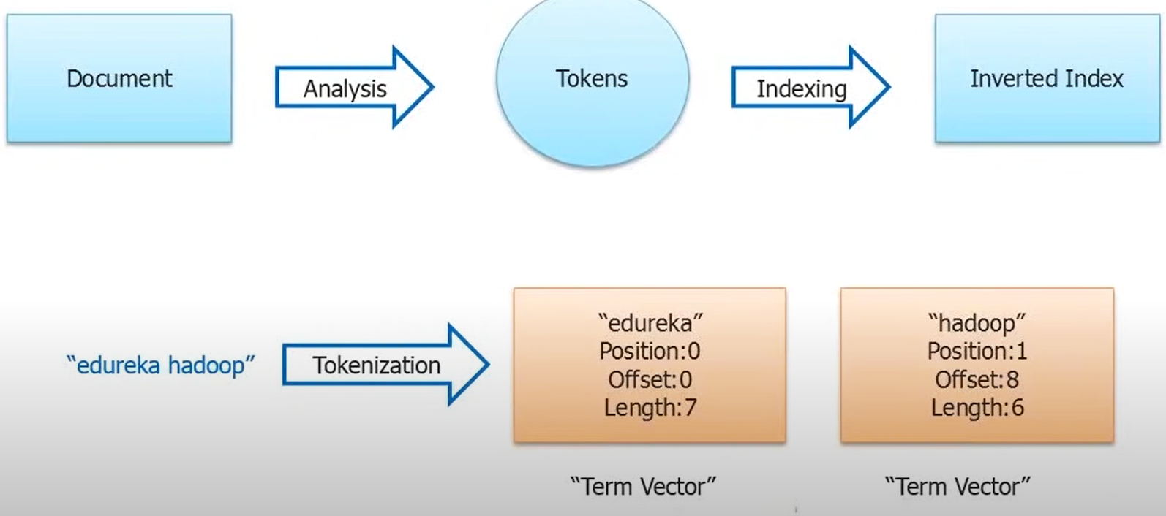

**Lucene Architecture**

**Indexing is the core layer of Lucene.**

**Indexing uses one or more analyzer as a strategy for index writing.**

**The analyzer purges Lucene documents from useless contents like space, hyphen, stopwords etc. depending on the chosen analyzer.**

***Analyzer is used for handling both indexing and search. both search as well as searching.***

**To search inside the index, the user must provide a human-readable expression called query string**

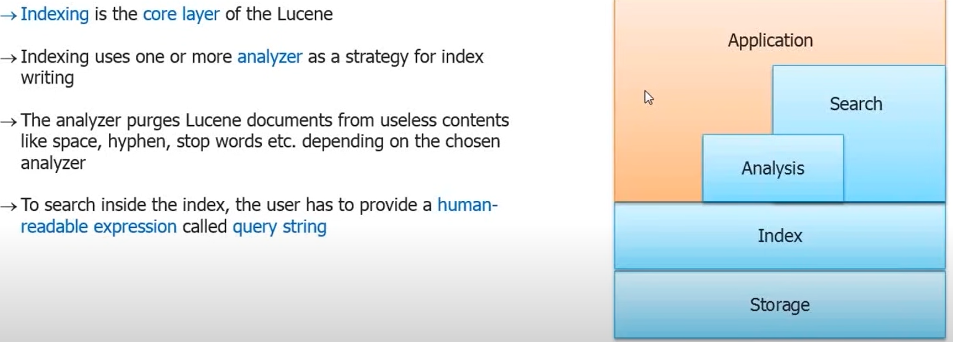

**When an application used any method to transfer documents. The documents are transferred into a document handler.**

**Document handler submits what received to an analyzer. The analyzer picks up the documents analyzes and submits into the index writer. Index writer then stores the document into the index storage.**

**To reads same documents, the human/components submit query to the query parser or search component and the query is returned to index searcher. Where the index searcher uses the index reader to read the index and return the top documents / top results.**

**Lucene-Inverted Indexing Technique**

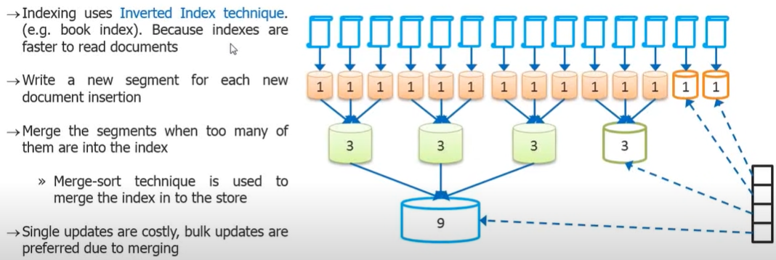

**Inverted index comes with cost .writing index for each words.**

**Merge-sort technique is used to merge index into the store.**

**What is indexing?**

**The** purpose of storing an index is to optimize speed and performance in finding relevant documents for a search query.

**Storage Structure of Lucene**

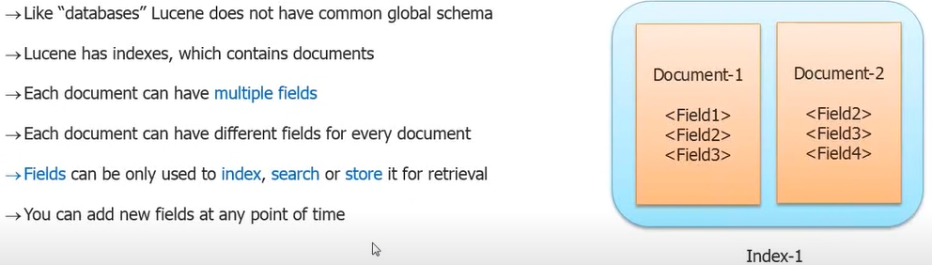

**Fields** can also be used to index, search, or store it for retrieval. You can add new fields at any point of time.

**Note**: Any two set of documents might not have same Fields, the defined fields of a document could be sparsely. This implies fields can vary from document to document.

At run time user can create Fields by their own.eg(created time,last modified)

Field can be used to index and store the document itself.

**A field can be index and omitted from storing**. => This implies the field can be searched but cannot be retrieved.

**A field can be stored but not index=>** This implies the field can be retrieved but cannot be searched

**Document**

A document is the atomic unit(a.k.a **Record**) of the index and can have **multiple fields.**

**Field**

Fields have **name** and **value.**

**(A field can be of multiple types)**

Raw content needed to be transformed before setting or using it in the document

Different documents can have different fields.

**Field May**

**Be indexed or not**

* Indexed fields may or may not be analyzed (i.e., tokenized with an Analyzer)
* Non-analyzed fields view the entire value as a single token (useful for URLs, paths, dates, social security numbers, etc.)

**Be stored or not**

* Useful for fields that you’d like to display to users

**Optionally store term vectors**

* Like an inverted index on the field’s terms
* Useful for highlighting, finding similar documents, and categorizations

**Field Classes**

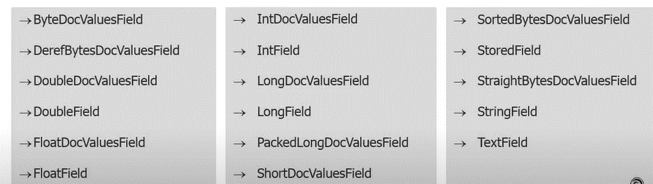

Lucene Field Options

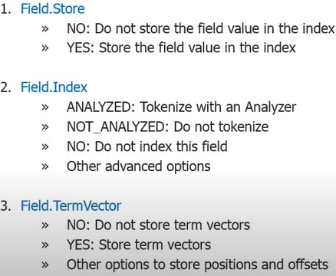

**Analyzers**

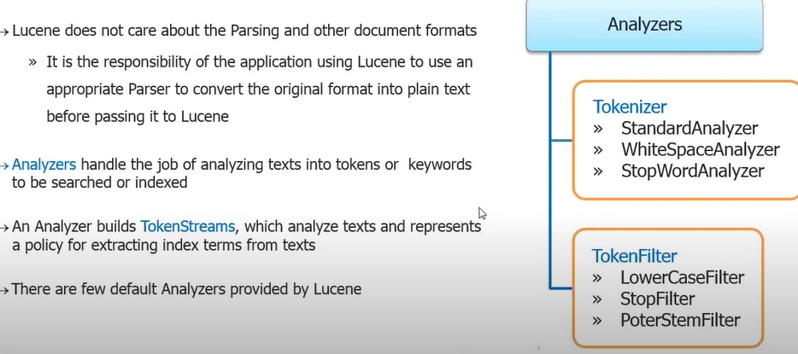

**Tokenization**

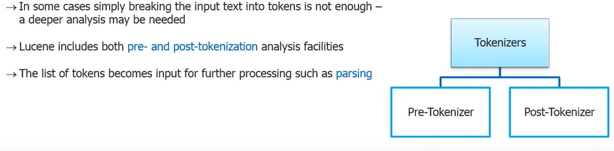

**Pre and Post Tokenization**

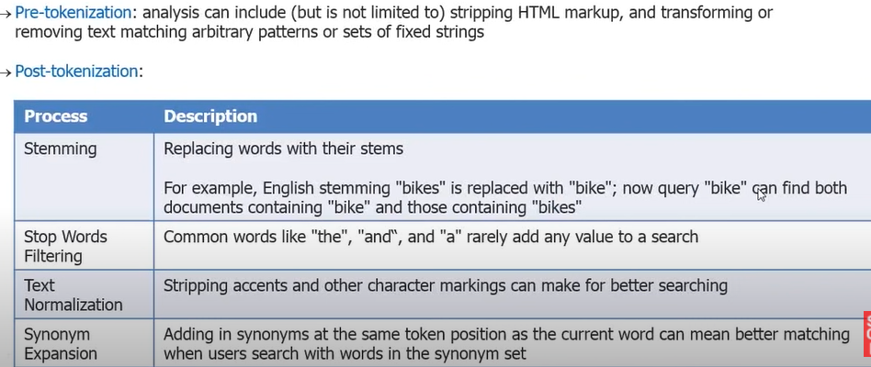

**Indexing Analysis vs. Search Analysis**

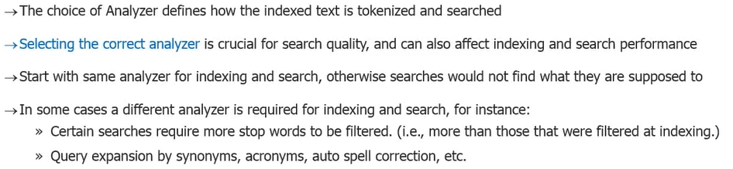

**Query Types**

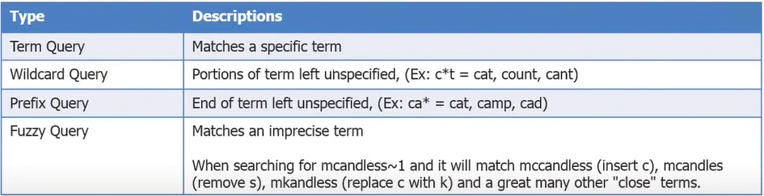

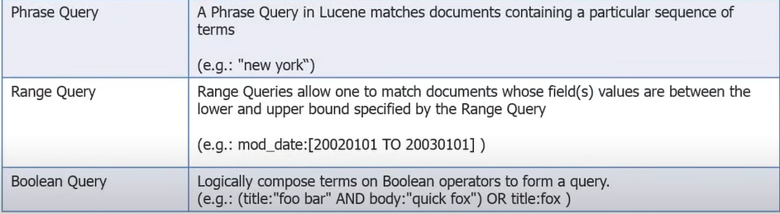

**Term queries** matches specific terms(**words**) in the document.

**Phrase Queries**: when search for phrases use the **phrase** queries (eg.[chicken sandwich])

**Writing Index Classes**

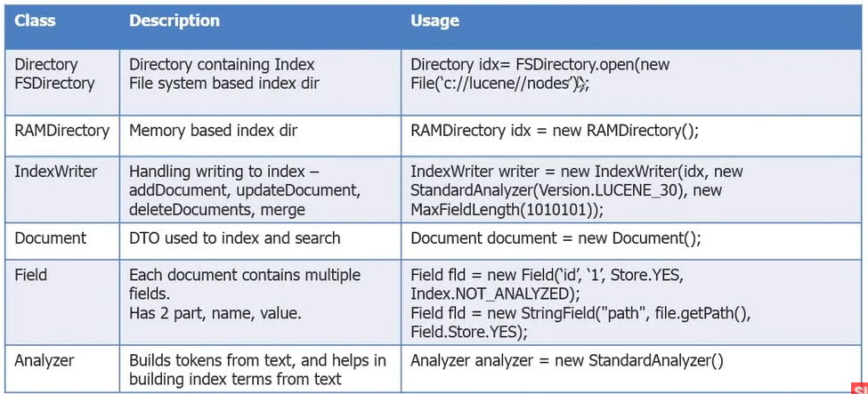

**Writing to Index**

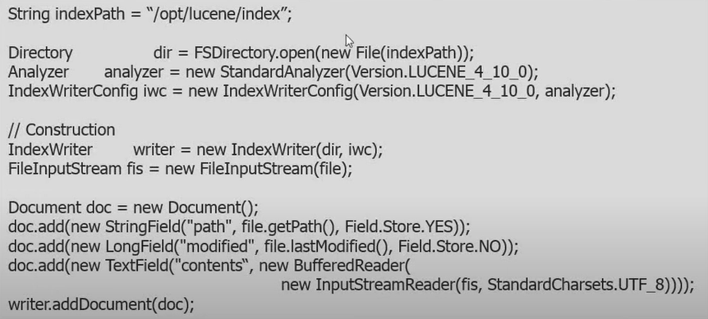

**Search In Index**

* Using the Api
* Using the Query parser Api(most familiar way)

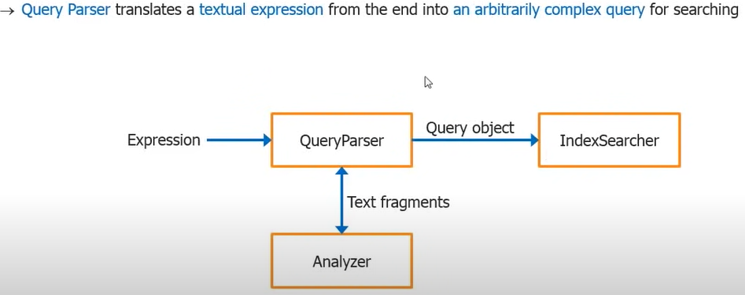

**Searching Index Classes**

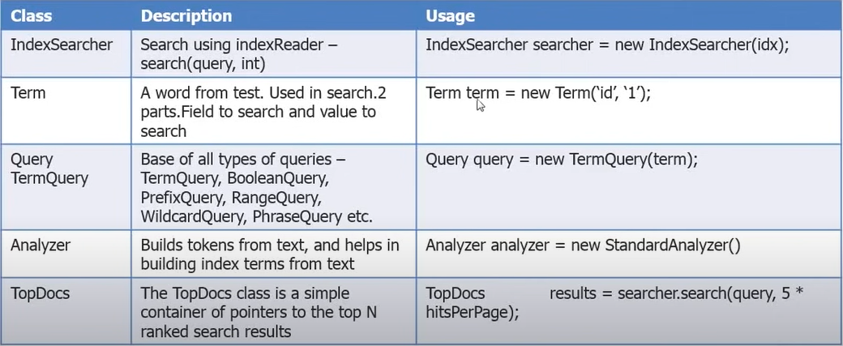

**High Level Flow**

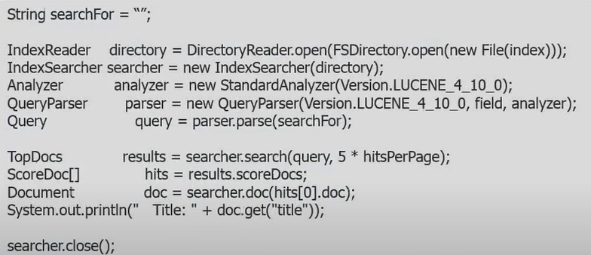

**Using API Libraries**

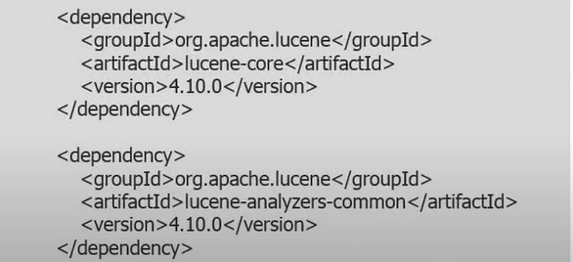

**Key Packages In Lucene**

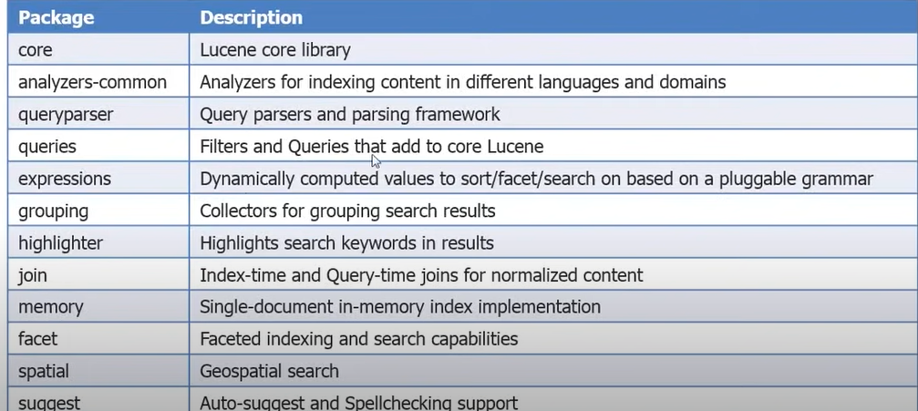

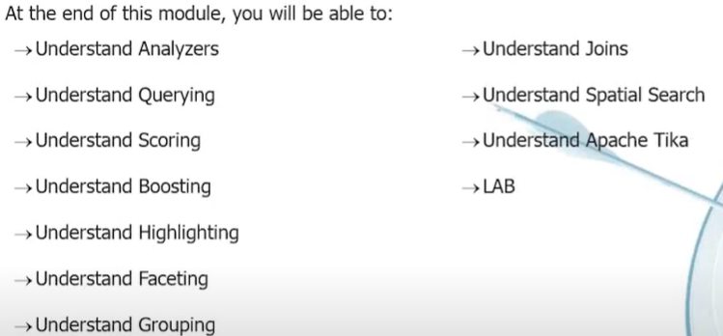

**Analyzers**

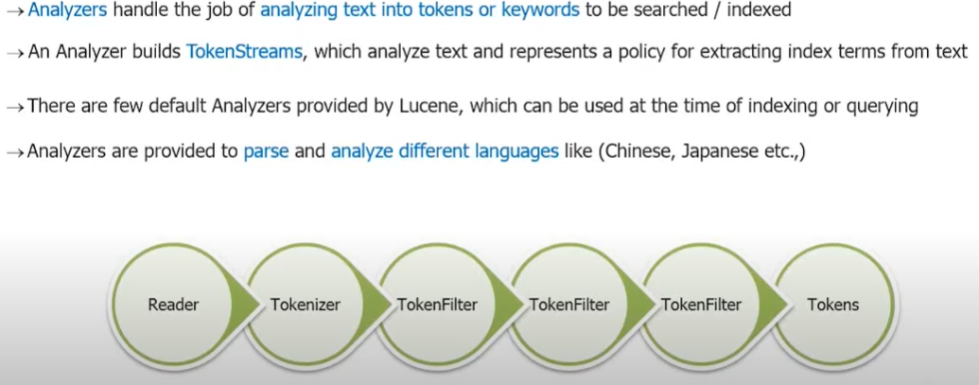

**The first step of analyzer is the tokenization process.**

Based on the next filters it filters words according to the filter applied.

There is more than one filter.This token filters can handle international languages.

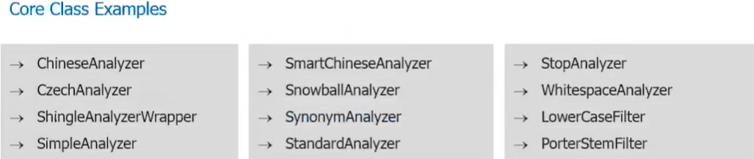

* **Simple Analyzer** first splits tokens at **nonletter character**, then lowercases each token.
* This analyzer **quietly discards numeric** characters but keeps all the other characters.
* An Analyzer that filters Letter Tokenizer with LowerCaseFilter.



**Standard Analyzer** is the most robust core analyzer

It has **logic** to identify certain tokens, such as company names, email address, and hostnames. It also **lowercases each token** and **removes stop words** and **punctuation**.

Filter **StandardTokenizer** with StandardFilter,LowerCaseFilter and StopFIlter, using a list of English stop words.



**Stop Analyzer**

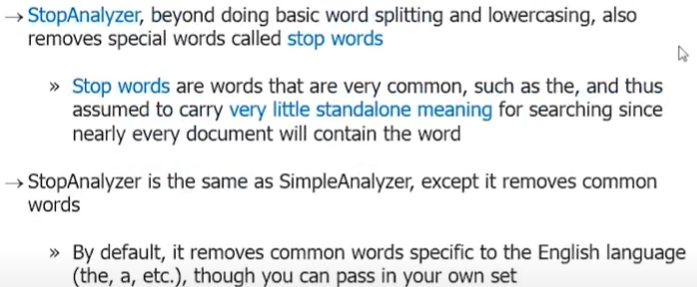



**Analyzer Stemming**

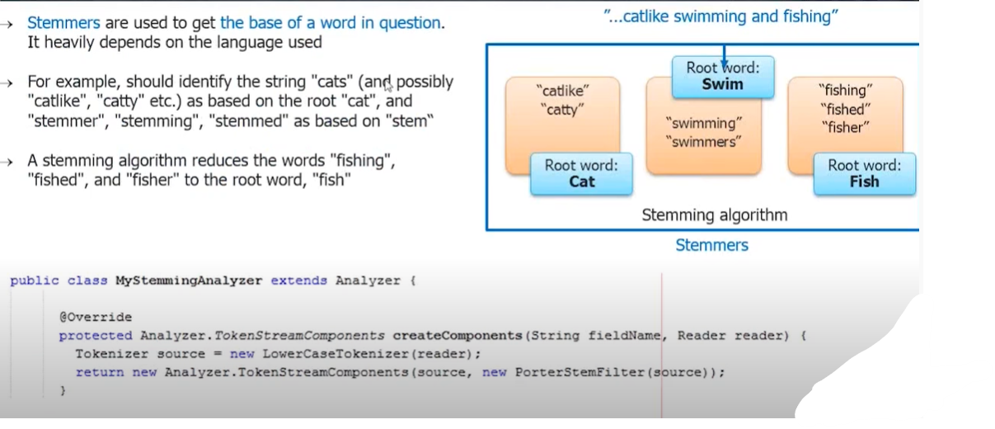

**Analyzers-Synonyms**



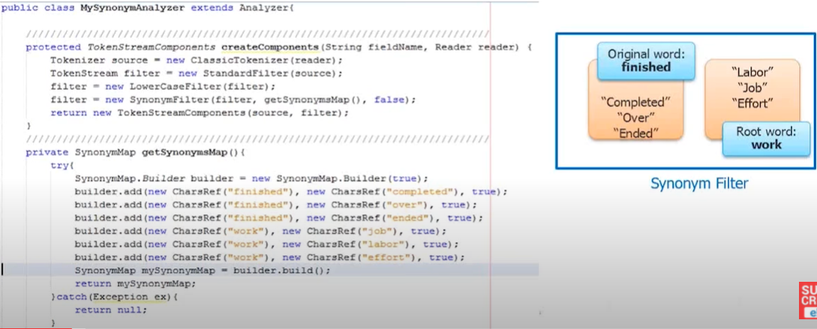

**Lucene Querying**

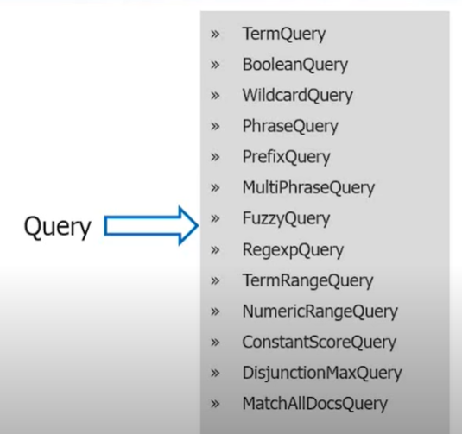

**Term Query**

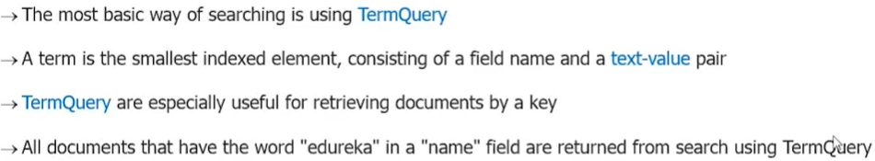

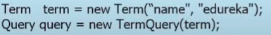

**TermRange Query**

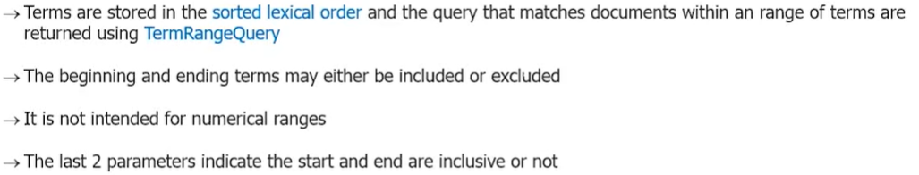



**Numeric Range Queries**

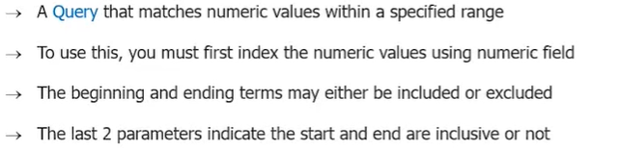



**Prefix Query**

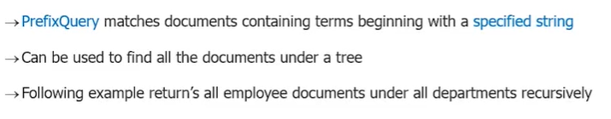



**Wild Card Query**

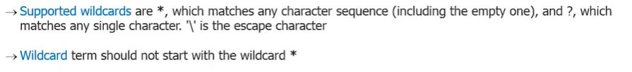



**Phrase Query**

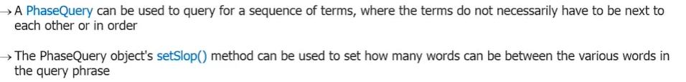

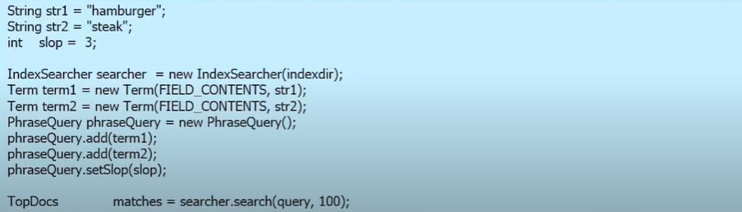

**Boolean Query**

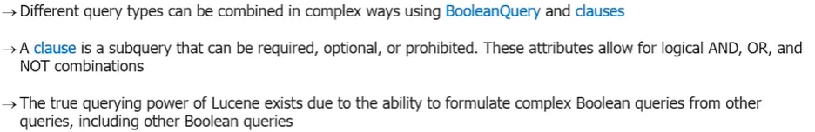

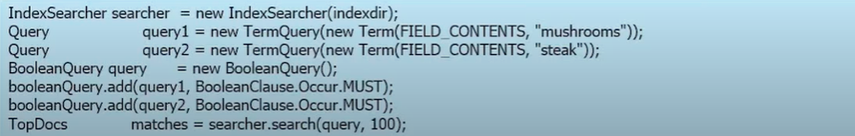

**Must-**The word have to exist

**Should-T**he word can exist or not

**MustNot-T**he word need NOT exist

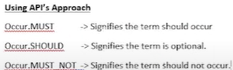

**Query Parser**

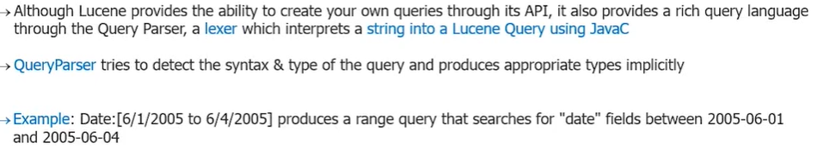

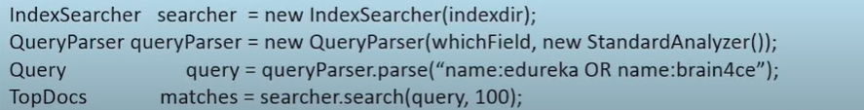

**Query Syntax**

**Terms**

A **query** is broken up into **terms** and **operators**

There are two types of terms: **Single Terms** and **Phrases**

>> A **Single Term** is a **single word** such as “test” or “hello”

**A Phrase** is **a group of words** surrounded by **double quotes** such as “**hello dolly**”

Multiple terms can be combined with Boolean operators to form a more complex query

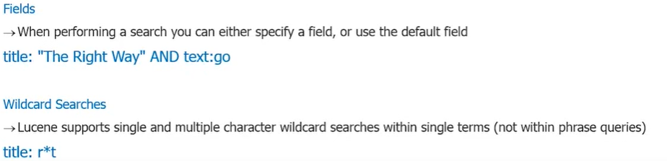

**NB:** Wild Cards cannot be used in the beginning.

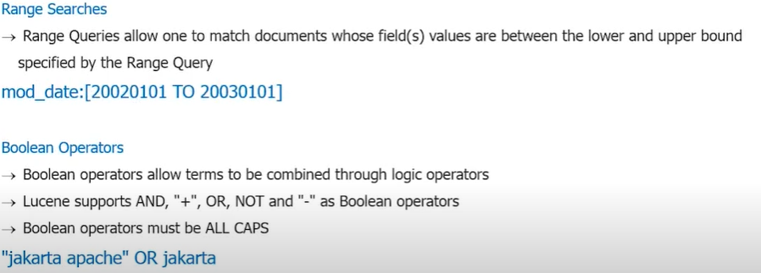

**Scoring**

**Sorting** documents by match quality

* By default, it uses **Vector Space Model (VSM) with TFIDF** weights to score documents.
* Lucene scoring is the heart of why it is so popular
* Scoring is very much dependent on the way documents are indexed
* In Lucene, the objects we are scoring are documents & fields.
* Lucene uses various ranking algorithms to assign score

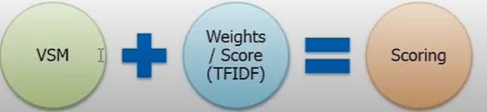

**Scoring-Vector Space Model (VSM)**

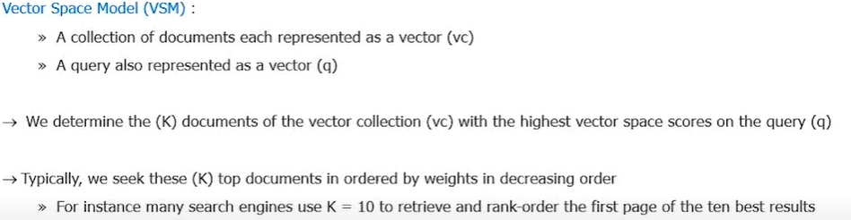

**Scoring-Similarities/Weight/Scores**

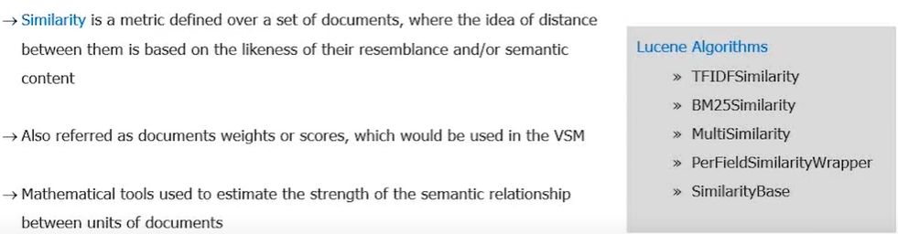

**Scoring-TDIDF Weights/Score**

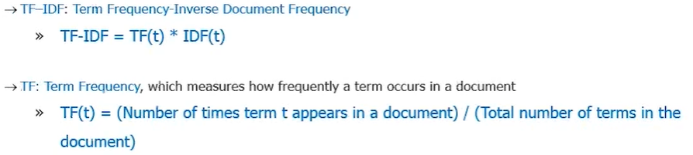

**Scoring-TDIDF Weight/Score**

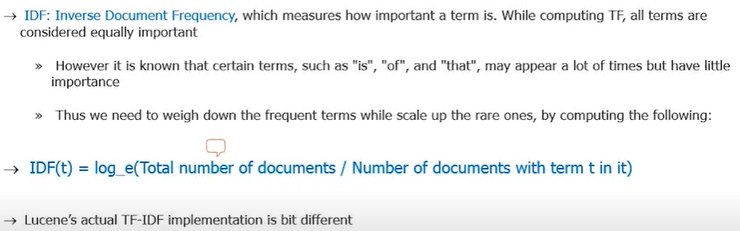

**Score Boosting**

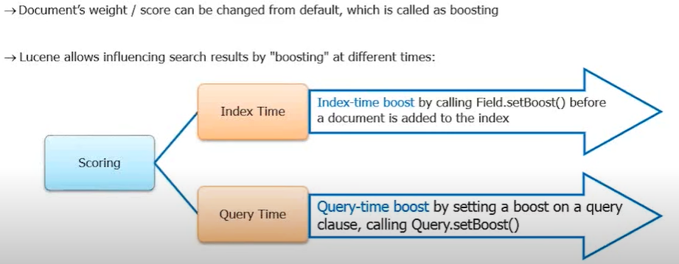

**Index Time Boosting**

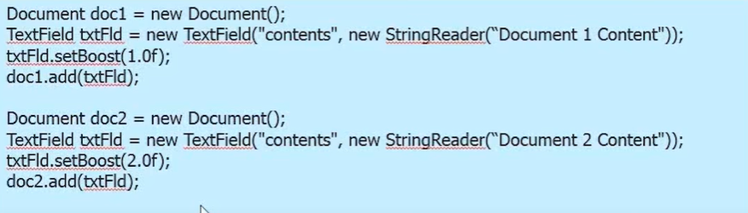

**Query Time Boosting**

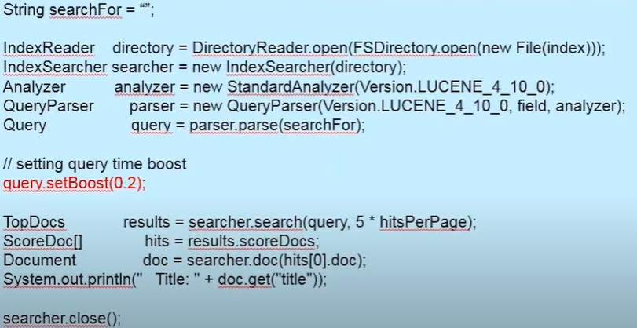

**Highlighting Term Queries**

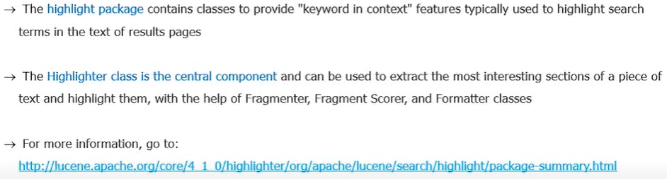

**Faceting**

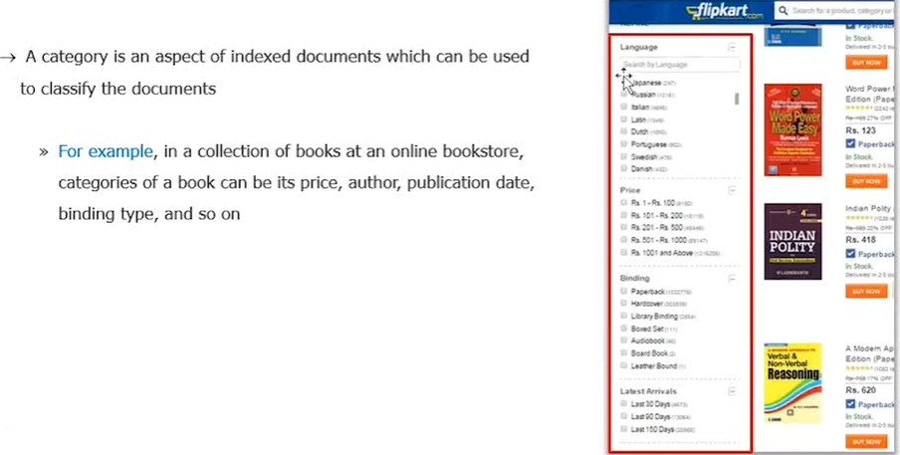

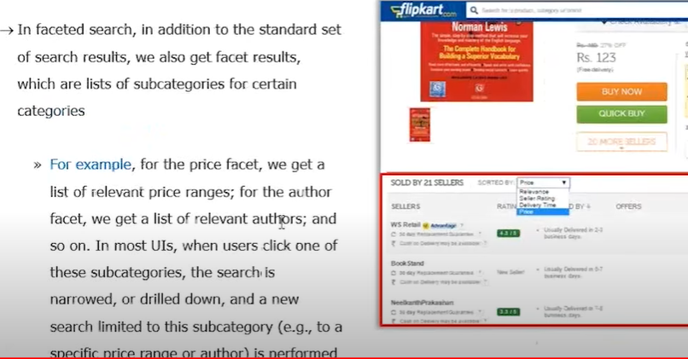

Grouping

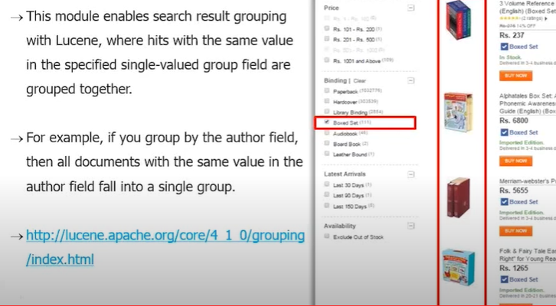

Joins

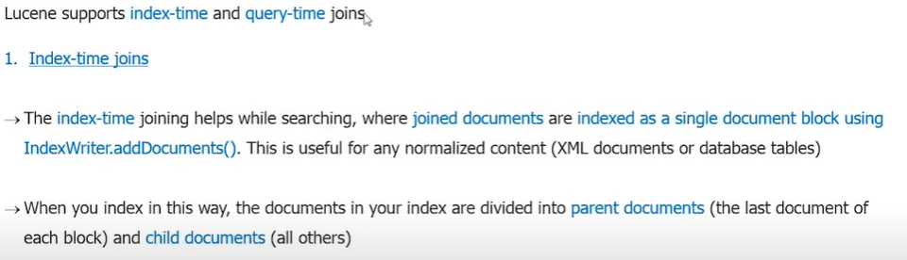

Spatial Search

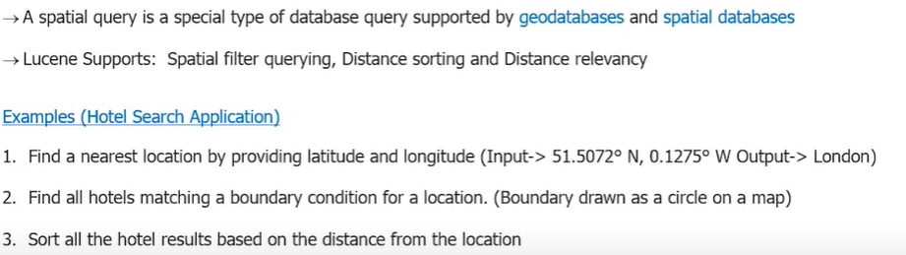

Apache Tika

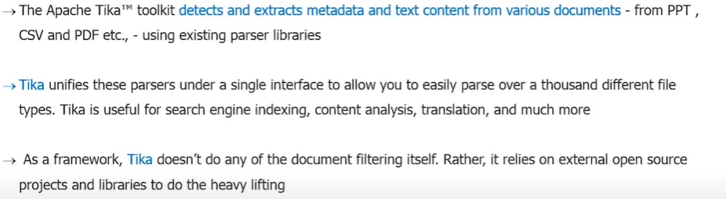

Apache Tika Supports

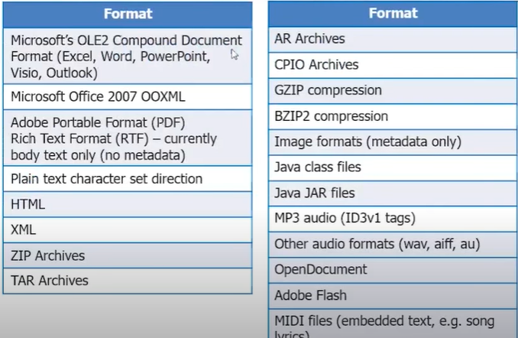

**Solr Introduction**

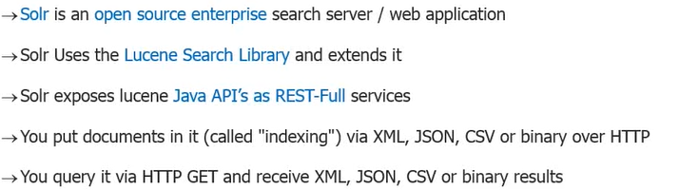

**History**

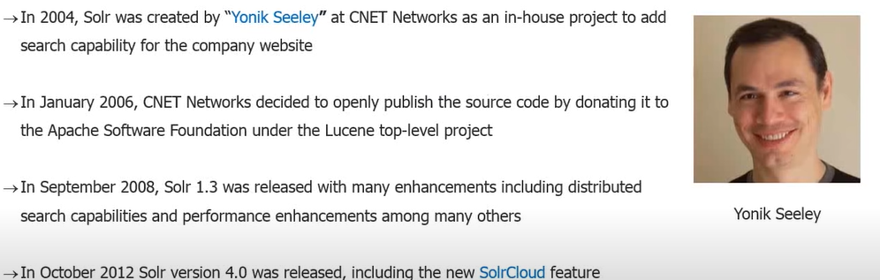

**Key Features**

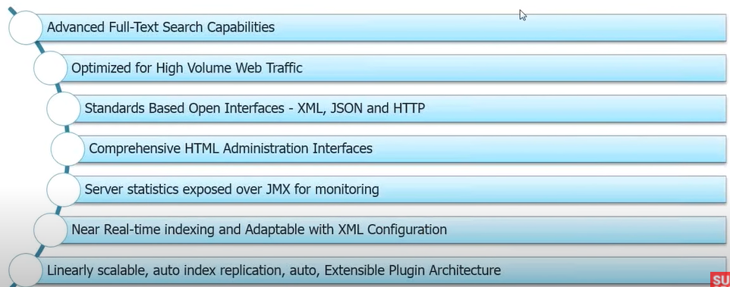

Architecture

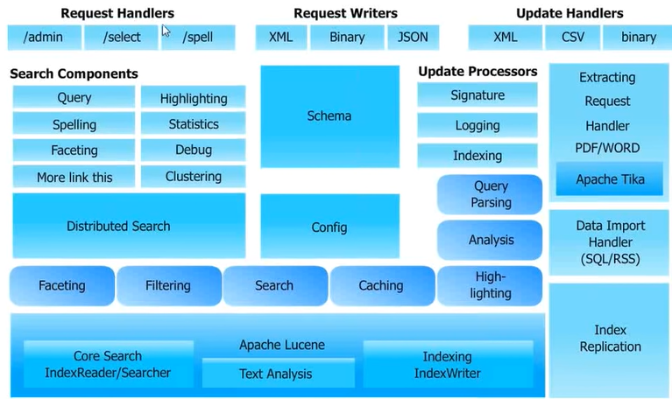

Schema Hierarchy

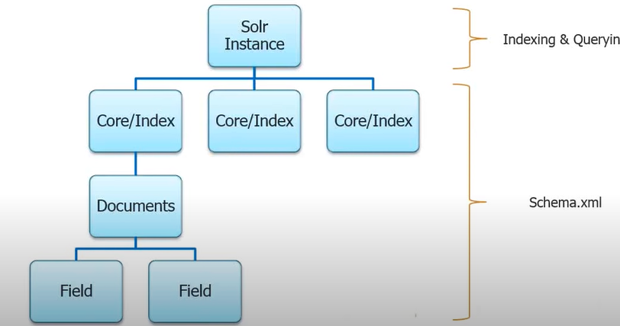

Core

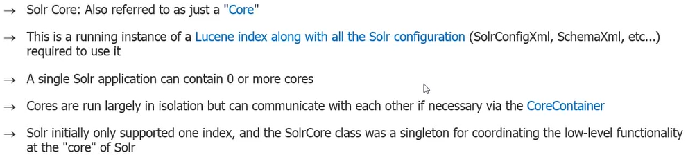

Documents & Fields

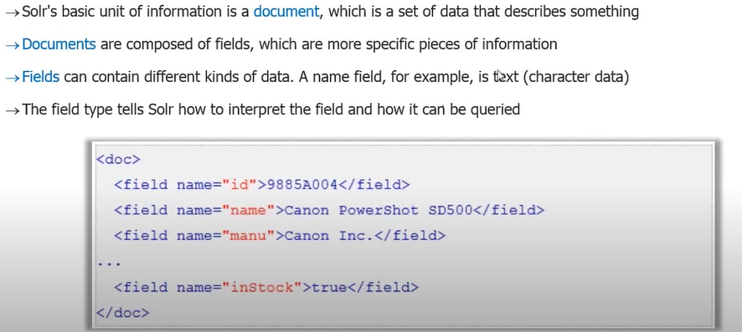

Indexing Data

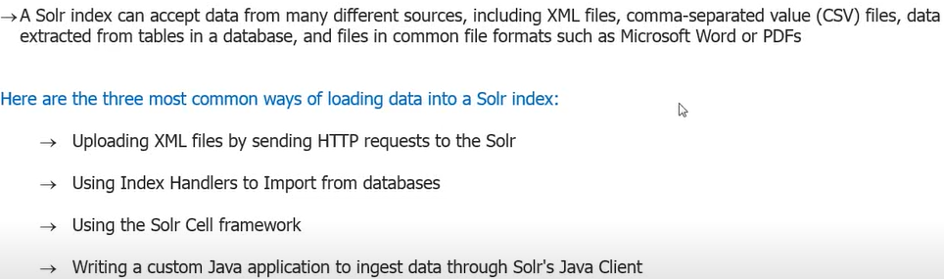

Analysis

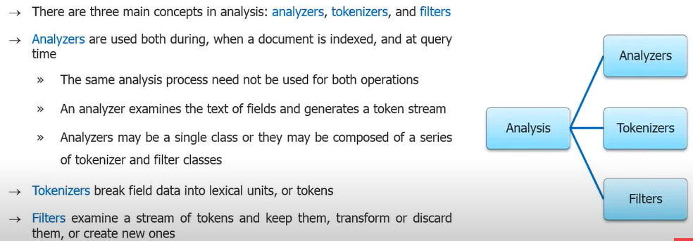

Solrconfig.xml

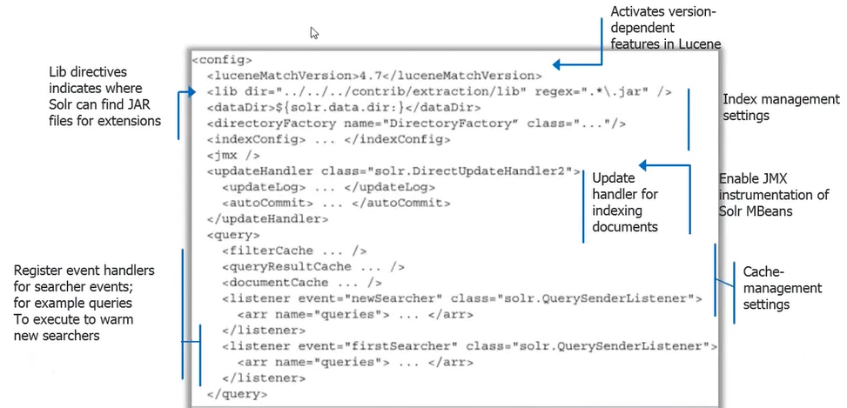

Search Process

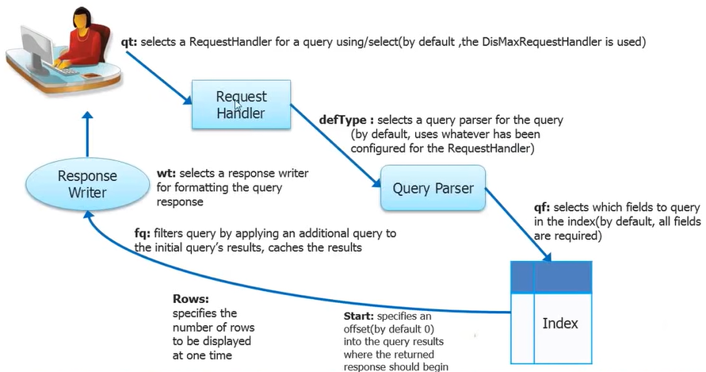

Solr Features

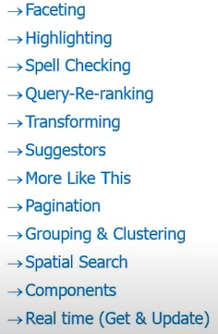

Configuring Solr Instances/Cores

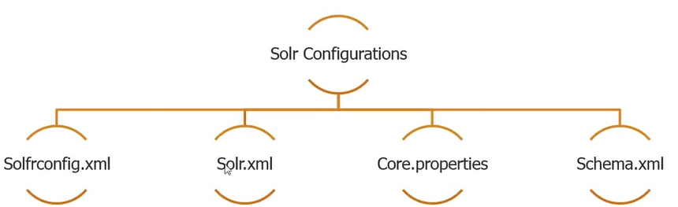

Solrconfig.xml

Configuration for all the indexing and search components

Sorl.xml

Configuration for all the entire solr level for all cores and the cores that exist

Core Properties

Configuration defining the setting properties for specific core

Schema.xml

Configuration core data structure level for defining fields and details for core.

SolrCloud Introduction

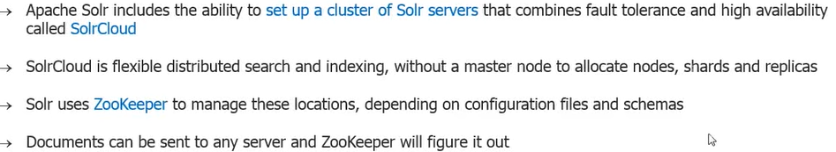

Features

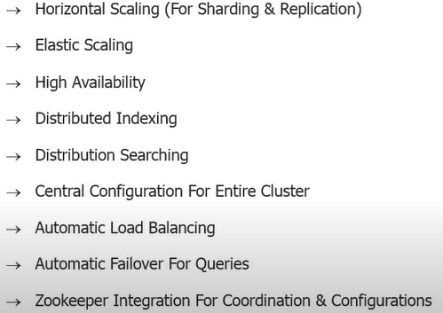

SolrCloud Architecture

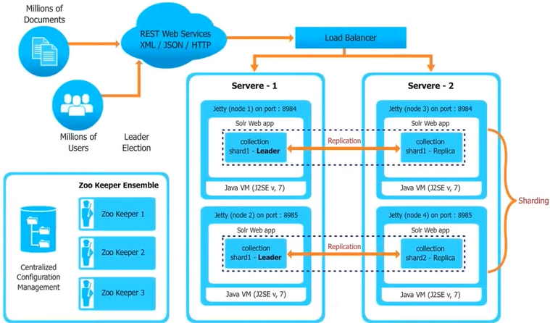

**Extensions**

Store libraries that are to be used in solr. /lib directory

**Directory Structures**

